Colin Morris-Moncada

Software Engineering

Professor Han

Exercise 5.20 digitRange

Screenshot 1

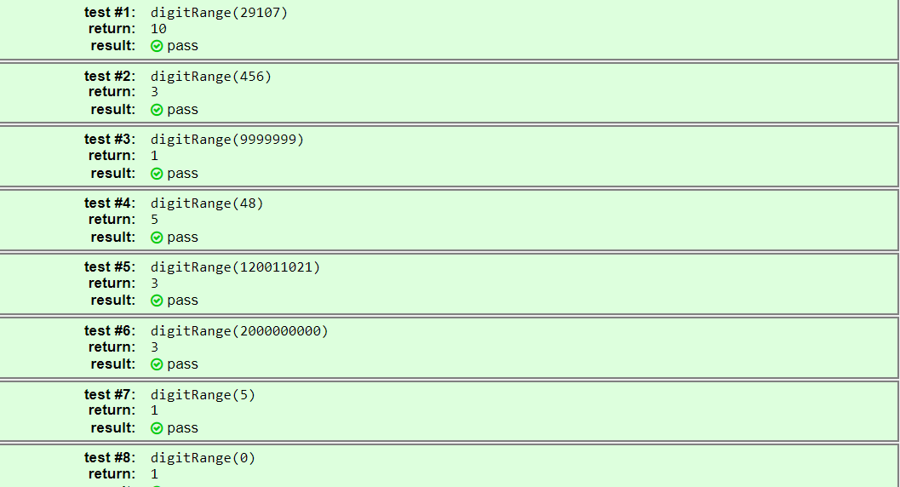

Screenshot 2 (next page)

